

Harrow High School & Sports College

Gayton Road
Harrow
Middlesex
HA1 2JG

Tel.: 020 8861 7300
Fax.: 020 8861 7307

22nd May 2009

Dear Parents/Carers and Learners,
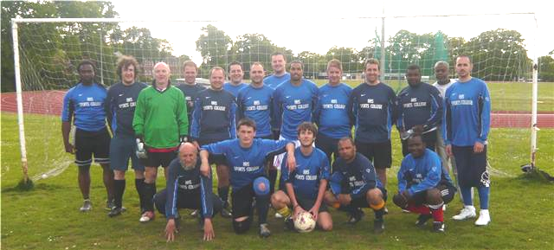
The Mighty Harrow High Athletic

The teachers now have their own team. They have played one match, coming a close second, but are well on the way to becoming an almighty team.
Come on the teachers!!!!

BBC Poetry Season
Spring 2009 sees the launch of a landmark commitment to the arts with a pan-BBC season dedicated to poetry.
Some of the nation's best loved poets and celebrities will take part in a season of big, bold content across television, radio and online; exploring the far-reaching, compelling and truly fascinating world of poetry.
Griff Rhys Jones launches the Poetry Season on BBC Two on 20 May at 9.00pm with a passionate plea about Why Poetry Matters – how verse has the power to move and why everybody needs it.


Also on BBC Two, My Life In Verse With... Robert Webb is the first in a four-part series exploring the rich terrain of poetry from Milton to Shakespeare through the eyes of four well-known personalities also including Sheila Hancock, Malorie Blackman and Cerys Mathews; and Off By Heart on Friday 22 May at 9.00pm follows primary school children across the country as they take part in a nationwide recitation competition, culminating in a grand final, compered by Jeremy Paxman.
For younger viewers CBeebies cooks up a fresh, daily serving of scrummy Poetry Pie in a specially created new series for three to six year olds. Starting on BBC Two on May 18 poets from Brian Patten, Roger McGough and Children's Laureate Michael Rosen to primary school pupils from across the UK contribute to a mix of funny and original rhythms and rhymes.

A dedicated website, bbc.co.uk/poetryseason, launching on 18 May, will feature a wealth of content including a vote to elect the Nation's Favourite Poet, with short films from a host of celebrities making their case for their favourite poet including John Sergeant on Betjeman and Alex James on Auden. Plus the Poetry Season's dedicated website will feature a poetry search engine to find poems according to a particular theme or mood.
George Entwistle, Controller Knowledge Commissioning, BBC Vision, says: "The Poetry Season offers viewers a fascinating and accessible insight into verse; there really is something for everyone.
"The UK has an extraordinary poetic tradition. We hope this season, the BBC's fantastic accompanying online offering, and the other initiatives with the likes of the Poetry Society will inspire and motivate people to discover and reacquaint themselves with the poetry greats. In addition it may also inspire them to discover their own poetic voice."
The BBC is working closely with external partners on the season including the Poetry Society and National Poetry Day.
As part of the BBC Poetry season we are asking you to contribute any poetry that you have written. If you are a poet and you know it, pass your poems to Ms. Ferry and we will do a wonderful display of them all.

Work Experience

Work Experience for the learners at Harrow High takes place between 1- 6 June 2009. Most of the year 10 students have now obtained their placements. They have obtained diverse workplaces such as Debenhams, St Luke’s Hospice, Opticians, Dentists (don’t think they will be doing any extractions or fillings just yet!), Waitrose, Hairdressers, Nurseries – both playgroups and plants, garages, Chartered Accountants, other Schools and so the list goes on……..one student obtained her own placement in Hamleys, London.

All the students are requested to ensure they arrive on time, are always polite and to remember they are representatives of Harrow High. Good Luck to them all!

Maths Challenge

Congratulations to the year 8 learners who participated in the National Maths Challenge. The following learners were our best performers and received awards as follows:
Pranjal Samarth – silver and best score in the school
Ehsanullah Janebdar – Bronze
Kailen-Kirk James-Mitchell – Bronze

Maths GCSE exams Dates:
Year 11 calculator paper – Monday 1st June (Learners must remember to bring their equipments – pens, pencil, ruler and calculator!)
Year 10 Unit 2 Thursday 11th June
Year 9 Unit 1 Thursday 11th June

Maths after school revision is on Thursdays (M5 and M7)
Good luck to learners sitting their exams!


Young People's Board of Directors for Sexual Health
This is a unique opportunity for Young People to lead on the strategy for Sexual Health and Teenage Pregnancy by being part of a Board of Directors. They will get training, a budget to manage, ability to educate other young people and a reference for their CV as well as the opportunity to have their say and have fun.
The only criteria is that they are 15-21 years old and live or go to school/college/work in Harrow.

An open day is being held on Thursday 4th June from 4-6pm at Civic 9, Milton House. No commitment necessary at this stage - just come along and check out what it is all about.


Wanted
We suspect this voucher and his posse are in hiding in Supermarkets and at the bottom of shopping bags.
If found please approach with caution and return to the ICT department.

Change to summer term dates – reminder
The school year 2008/09 is an exceptionally demanding year for High Schools. We are managing change on an unprecedented scale: new KS3 curriculum; new GCSE courses, vocational courses and functional skills courses at KS4; new ‘A’ level courses; moving into our superb new 6th Form extension at the end of the school year; (provisional) planning for Year 7 admissions in September 2010.
In order to ensure that we manage this change successfully, maintain standards and have all the new courses well prepared, planned and resourced we have decided, in conjunction with a number of other High Schools in Harrow, to close school for learners on Wednesday 15th, Thursday 16th and Friday 17th July. This will give staff vitally needed additional time devoted to preparation and planning.

We will, of course, provide supervised activities in school between the 15th and 17th July for learners who are unable to stay at home on those days. Arrangements for this will be made nearer to the time.

Yours sincerely
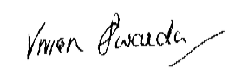
V. Swaida
Headteacher

